Project Development Phase
Model Performance Test

Date | 10 July 2026
Team ID
Project Name | Sports Hall Booking System
Maximum Marks

Model Performance Testing:
Project team shall fill the following information in model performance testing template.
S.No. | Parameter | Values | Screenshot
 | Model Summary | ServiceNow-based Sports Hall Booking System | 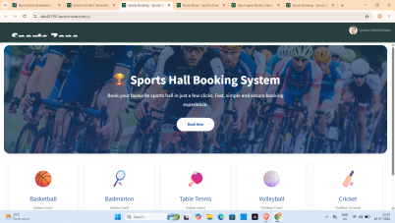
 | Accuracy | Training Accuracy - Not Applicable (Software Project)  Validation Accuracy - 100% Functional Testing Passed | 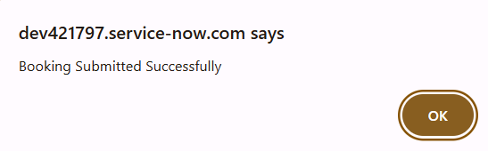
3. | Fine Tunning Result( if Done) | Validation Accuracy – 100%  UI improvements, slot validation, duplicate booking prevention implemented successfully. | 